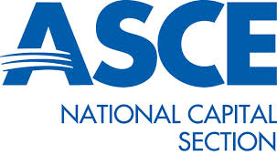

Call for Presentations

Guidelines and Submission Form

ASCE National Capital Section

Geotechnical Executive Committee

Geotechnical Symposium on Innovations and Lessons Learned in Ground Improvement

April 15, 2020

Tyson’s Corner Marriott, 8028 Leesburg Pike, Tysons Corner, VA 22182

Deadline for Abstract Submission: December 13, 2019

This year’s symposium will focus on Ground Improvement. Topics for this event include, but are not limited to, recent innovations in ground improvement technologies, lessons learned, project case studies, design topics, monitoring and performance, numerical analysis, and ethics.
Please submit an abstract 300 words or less electronically in MS Word or Adobe .pdf format) to kowens@geostructures.com. A completed submission form is also required.

Accepted presenters will be notified by January 13, 2020.

By submitting your abstract, you agree that, if your presentation is selected, you will provide your resume, a copy of your presentation in .pdf format, and questions that can be used for a learning assessment by March 2, 2020 to allow for PDH approvals by the various engineering boards.

Presenters should be prepared to bring their presentation, formatted in MS Power Point, electronically saved on a flash drive. A laptop computer, projector, screen, and laser pointer will be available. Any other special requirements should be noted on the submission form.
Geotechnical Symposium on Innovations and Lessons Learned in Ground Improvement
Presenter Abstract Submission Form

Topic:

Number of presenters (Note: only one presenter will be provided complimentary attendance for the symposium)

Name(s) of presenter(s) with affiliation:

Total time requested for presentation (select one):

___30 min ___60 min

(Assume 5 minutes for Q&A)

Abstract:

